COURT de WYCK CHURCH SCHOOL THEME OVERVIEW
Class: Robin Year: R/Y1 THEME: Me and my world Term: Autumn 1&2, 2025
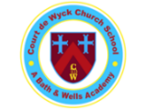
Our curriculum is child-centred, aspirational and purposeful to instil within our pupils the knowledge, skills and confidence needed for their
ever-changing futures.
Presentation of learning/wow days/trips/visitors    - Starting School  - Local area walk  - Harvest  - Clevedon Pier  - Christmas Play  - Annual trip to the pantomime  - Trip to Holy Trinity Church for Xmas service | 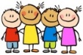  Children’s Interests  - Their family and pets  - Sharing their special boxes  - Bonfire Night  - Christmas |   Christian Values Link  - Respect  - Compassion
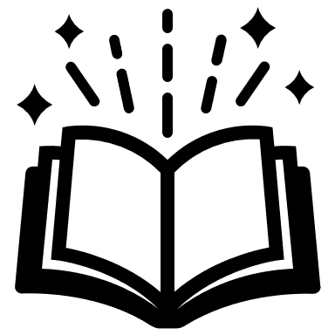  Literacy  Phonics - Phase 2 introducing sounds and CEW  Y1 – Phase 4 recap & Phase 5. Spelling CEW and words with familiar sound patterns  Writing for a range of purposes  Sentence transcription  Possible stories:  - In Our Hands (Whole school text)  - Here We Are  - What We’ll Build  - Sidney, Stella and the Moon  - Anansi  - Look Up  - Naughty Bus |   EYFS Mathematics  - Matching and sorting  - Compare size, mass and capacity  - Exploring pattern and shape  - Number recognition, counting and comparing  - Composition of numbers to 5, 1:1 counting  Y1 Main focus on number skills  - Place Value, addition/subtraction, partitioning  - Measure  - Money  - Multiplication & division by 2  - Fractions – halves & quarters  - Shape  - Time | Communication & Language  - Listening to and sharing familiar stories and nursery rhymes  - Following simple instructions  - Sharing news  - Listening to others  - Asking & answering questions  - Sharing special boxes / their learning  - Hot seating characters  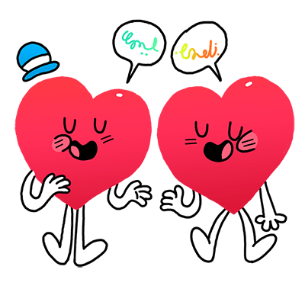  - Show and Tell  - Small world play  Y1 Computing  Simple keyboard skills
  Personal, Social & Emotional Development    - Settling in  - Feelings and emotions – Colour Monster and  Zones of Regulation  - PANTS – trusted adults  - What makes a good friend?  - Looking after each other  - Similarities and differences  - Classroom contract  - JIGSAW - Being Me in my World  - Celebrating Difference |   EYFS Understanding of the World  - Discuss similarities/differences between themselves, others and animals  - Who is in their family? Are all families the same?  - Weather, Autumn, observations of the world around us – space, sun, stars  - What materials are our homes made from?  Y1 Science  Everyday materials  Y1 Geography  Local area – focus on Clevedon and Clevedon Pier  Y1 History  How has communication and travel changed over the years? |   RE and SMSC  - Who are we?  - Why are sometimes special?  - What makes every single person unique and precious?  - Why is Jesus important?  - Class worship  - Harvest, Diwali, Christmas  - Reflection Journals (Window, mirror, Door)  - Reflection Area
Expressive Arts and Design    - Collages using different textured materials  - Skills to make holes, attach things, joining  - Junk modelling  - Colour mixing  - Small world & role play  - Learning songs – worship, Harvest, Christmas  - Diwali art  Y1 Art  Drawing - Artist - Pablo Picasso - portraits  Print - Artist - Jasper Johns  Y1 DT  - Structures - Bridges  Y1 Music  - Charanga- Me and Hey You | 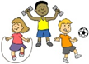  Physical Development  - Getting ready for PE  - Taking their coats on and off  - Explore sizes and different ways of moving and jumping through movement  - Games in PE involving space negotiating, starting & stopping, balance, direction change  - Mark making using different media  - Dough Disco  - Letter formation using different media  - Snipping with scissors, cutting along a line  Y1 PE  Invasion Games  Gymnastics | 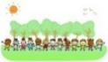  Outside Learning  Forest Explorers  - 1,2,3 where are you?  - Natural self- portraits / nature scenes  - Magical tree spirits  - Leaf animals / rubbing  - Story stones  Outdoor area  - Mud kitchen/Natural paintbrushes  Y1 Forest School – Lunchtime Club | Home Learning  - Show and Tell  - Reading and sharing stories  - Sharing ‘My Family’ pictures  - Practising sounds for blending  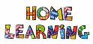  - Y1s spellings  - Numbots

