Daily Times
Tuesday 7th May 2024 The Heart of Britain £2.20
METAL MONSTER SIGHTED ON TOP OF LOCAL CLIFF.
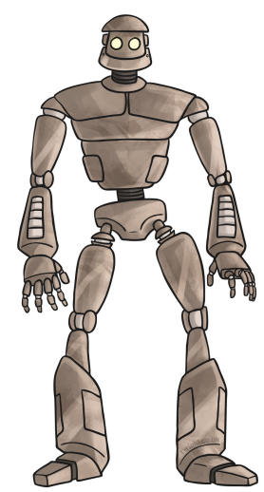 | Yesterday, during the hours of early evening around 6.00pm, it has been reported that something that can only be described as an ‘Iron Man’ was sighted standing at the very brink of Sandy Bay Cliffs.  Hogarth Trueman, age 10, the son of a local farmer, was out fishing in a stream when the sighting was made. The boy said, “Suddenly I felt a very strange feeling, as if I was being watched. I turned around and looked up the steep field to the top of the high cliff. Behind that skyline was the sheer rocky cliff and the sea. And on that skyline, just above the edge of it, in the dusk, were two green lights. I remember thinking, what were two green lights doing at the top of the cliff?”  Hogarth recalls feeling very afraid.  Hogarth went on to report that he could not believe what he saw happen next and as he watched, he saw a huge dark figure climb up over the cliff-top. “The two green lights suddenly rose into the sky,” he exclaimed. “They were the giant figure’s eyes!”  He then went on to recall, “It was a giant black figure, taller than a house, black and towering in the twilight, with green headlamp eyes. It looked like an Iron Man! I couldn’t believe my eyes.”  Feeling absolutely petrified, Hogarth left all of his fishing equipment and quickly ran home. When interviewed Mr Trueman said that when his son returned, he was “shaking like a leaf.” He described Hogarth as gasping for breath as he told him and his mother what he had seen. He kept repeating, “It was an Iron man! It was an Iron Man!” When asked if he thought the story was true, Mr Trueman said, “I absolutely believe my son.”
Above: The ”Iron Man” as described by 10 year old Hogarth Trueman.
Below: The most recent pictures of Mr Trueman and his son Hogarth on their farm, taken before the sighting.


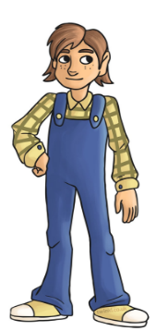

The local police have warned the public not to approach the “Iron man” if sighted again and to immediately dial 999.

