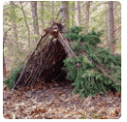
Shelter and Shade

This term in DT we are going to be looking at the purpose of shelters and their materials. Over the rest of the week and weekend when you are out and about, see if you can find any of these shelters.
Tick the boxes of any shelters you see and bring your sheet back to school on Monday 6th November.


