COURT DE WYCK CHURCH SCHOOL THEME OVERVIEW
Class: Owl Year: 1/2 Theme: Movers and Shakers Terms: Spring:Term 3 and 4
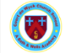
Our curriculum is child-centred, `aspirational and purposeful to instil within our pupils the knowledge, skills and confidence need for their ever-changing futures.
  Presentation of learning/wow days/trips/visitors  - Space dome  - Space museum  - Space day  - Survival experience |  | 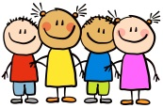  Children’s Interests  - Animals/pets  - Drawing/art  - Ball games |   Christian Values Link  Perseverance, courage, compassion, responsibility and hope.
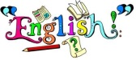  English  Talk for Writing Texts:  - Man on the Moon by Simon Bartrum-writing from another perspective.  - Non Fiction Texts: Neil Armstrong/Moon Landing.  - Beegu by Alexis Deacon.  - Letters from Rosa Parks. |  | 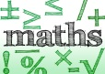  Maths  - Money  - Multiplication and division  - Length, height and perimeter  - Mass, capacity and temperature  - Fractions | 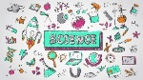  Science  Habitats and Human Survival  Habitats project teaches children about habitats and what a habitat needs to provide. They explore local habitats to identify and name living things and begin to understand how they depend on one another for food and shelter.  Human Survival project teaches children about the basic needs of humans for survival, including the importance of exercise, nutrition and good hygiene. They learn how human offspring grow and change over time into adulthood.
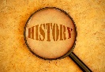  History  Movers and Shakers  This project teaches children about historically significant people who have had a major impact on the world. They will learn to use timelines, stories and historical sources to find out about the people featured and use historical models to explore their significance. |  |   Geography  Let's Explore the World  This essential skills and knowledge project teaches children about atlases, maps and cardinal compass points. They learn about the characteristics of the four countries of the United Kingdom and find out why there are hot, temperate and cold places around the world. They also compare England to Somalia. Children carry out fieldwork, collecting primary data in their locality to answer geographical questions. | Art and DT  Mix It 2 and Still Life  The project Mix it 2 teaches children about basic colour theory by studying the colour wheel and colour mixing. It includes an exploration of primary and secondary colours and how artists use colour in their artwork.  Still Life project teaches children about the work of significant still life artists and still life techniques. They explore a wide variety of still lifes and learn about the use of colour and composition. They create still life arrangements and artwork.  Remarkable Recipes  This project teaches children about sources of food and tools used for food preparation. They also discover why some foods are cooked and learn to read a simple recipe. The children choose and make a new school meal that fulfils specific design criteria.
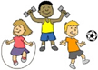  Physical Education  Primary Sports  - Dance  - Netball/  handball | 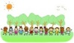  Outdoor Learning  - Shelter building/survival skills. | 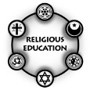  RE and SMSC  Understanding Christianity:  - Understanding Christianity- Gospel-What is the Good News Jesus Brings?  - Understanding Christianity-Salvation-Why Does Easter Matter to Christians? |  |   Music  - Focus on Dynamics and tempo  - Composing and using your imagination |   Computing  - Simple computing skills, login, using a keyboard and mouse control.  - Programming. | RHSE- Jigsaw  - Dreams and Goals  - Healthy Me
Cultural Diversity

- Celebrations-Easter
- Different foods in different countries
- Culture comparassion between England and Somalia
- Historical people from different cultures.

